Sci 9 Chem 8 Notes Name:

Objectives: By the end of the lesson you should be able to:
__________________________________________________________________________________________________________________________________________________________________________________________________________________________________________________________________________________________________________________________________________________________________________________________________________________________________________________________________

Recall…
- Ionic compounds have a __________________ and _________________ part (metal and non-metal)
- Covalent compounds have 2 _________________________ parts (2 non-metals)
- So, covalent compounds have to _________________electrons instead of transferring them like ionic compounds

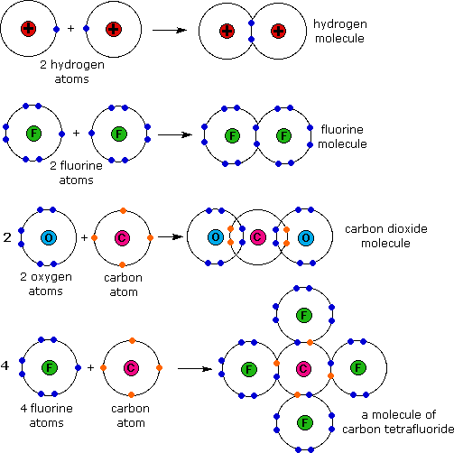

Naming Covalent Compounds
- Name first element
IF first atoms is 1 DO NOT add “mono”

- Name second element with “ide” ending
- Add any needed prefixes

Prefix # Atoms
Mono 1
Di 2
Tri 3
Tetra 4
Change any “oo” to “o”
I.E. monooxide = monoxide

Penta 5
Hexa 6
Hepta 7
Octa 8
Nona 9
Deca 10

Naming Practice
Making Covalent Compounds
- Write each symbol
- Add in any subscripts as per prefixes

Formula Practice:

Ionic Vs Covalent

IONIC COVALENT

